**Horizon-Base Indirect Lighting,  
Calculation Details**

## The ideal companion for your far-field indirect lighting solution.

February 2018 – Benoît “Patapom” Mayaux  
b.mayaux@gmail.com

Bent Normal

In order to first get the bent normal, we need to compute the average direction of a vector weighted by the cosine of the angle with the normal (since directions at grazing angles don’t contribute much to the bending) and unobscured by the heightfield:

$$\begin{aligned}\tilde{n}=\frac{1}{N}\sum_{i}^{N}{V\left(ω_{i}\right)}ω_{i} \#\left(4\right)\end{aligned}$$

Where:

* $\tilde{n}$ is the resulting average “bent normal” (in camera space)
* N is the amount of hemispherical samples
* $ω_{i}$ is the direction of the ith sample (in camera space)
* $n$ is the direction of the normal to the surface (in camera space)

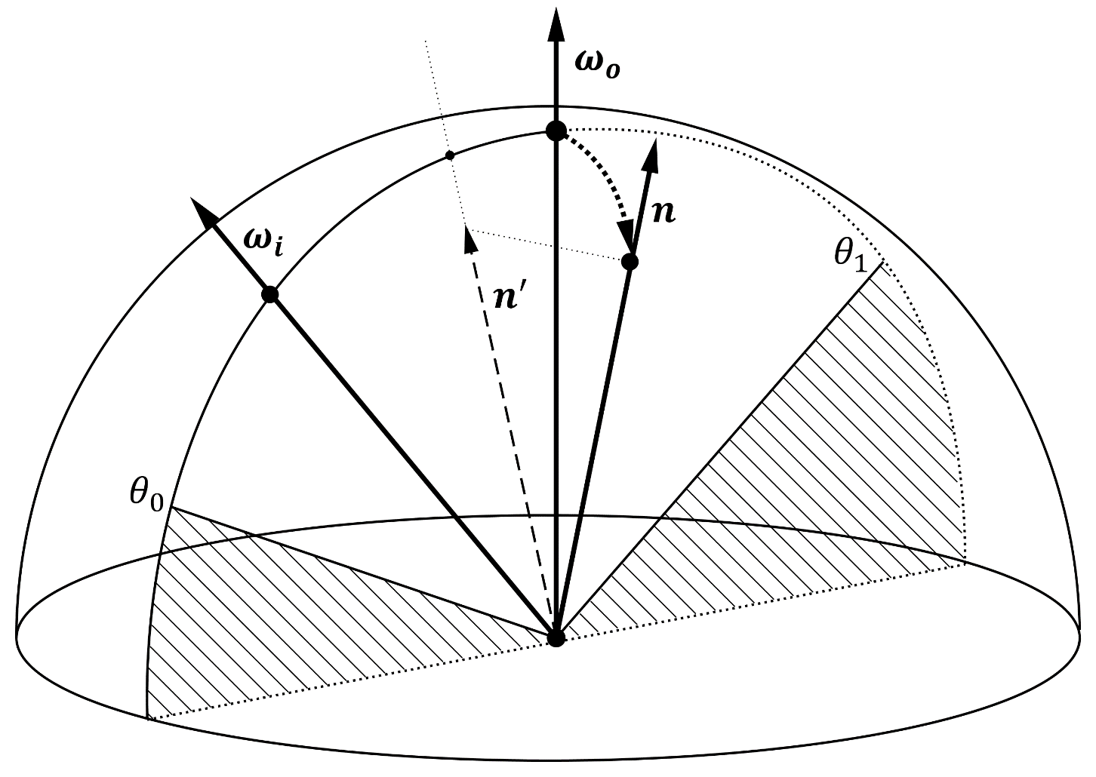

Fig. 10. Integration of the vector $ω_{i}$ in the slice between angles $θ_{0}$ and $θ_{1}$ weighted by the dot product with normal vector $n$. Notice that the normal vector $n$ is not necessarily lying in the slice’s plane.

We can compute the exact integral for equation 4 in our 2D “slice space” by writing:

$${ω'}_{i}=\left\{\begin{matrix}\sin\left(θ\right) \\ \cos\left(θ\right)\end{matrix}\right. \\ n^{'}=\left\{\begin{matrix}n_{x} \\ n_{y}\end{matrix}\right. \\ θ_{0}=back horizon angle , θ_{0}∈[-π,0]$$

$$θ_{1}=front horizon angle , θ_{1}∈[0,π]$$

$$\begin{aligned}{\tilde{n}}_{x}=\int_{θ_{0}}^{θ_{1}}{\sin\left(θ\right)\left|\sin\left(θ\right)\right| dθ} \#\left(5\right)\end{aligned} \\ \begin{aligned}{\tilde{n}}_{y}=\int_{θ_{0}}^{θ_{1}}{\cos\left(θ\right)\left|\sin\left(θ\right)\right| dθ} \#\left(6\right)\end{aligned}$$

Equation 5 can be expanded into:

$${\tilde{n}}_{x}=\int_{0}^{θ_{1}}{\sin^{2}\left(θ\right)dθ}-\int_{0}^{-θ_{0}}{\sin^{2}\left(θ\right)dθ}$$

$${\tilde{n}}_{x}=\frac{1}{2}(θ-\sin\left(θ\right)\cos\left(θ\right))\left|\begin{matrix}θ_{1} \\ -θ_{0}\end{matrix}\right.$$

$${\tilde{n}}_{x}=\frac{1}{2}(θ_{1}-θ_{0}+\sin\left(θ_{0}\right)\cos\left(θ_{0}\right)-\sin\left(θ_{1}\right)\cos\left(θ_{1}\right))$$

Similarly, equation 6 gives:

$${\tilde{n}}_{y}=\int_{0}^{θ_{1}}{\cos\left(θ\right)\sin\left(θ\right) dθ}+\int_{0}^{θ_{0}}{\cos\left(θ\right)\sin\left(θ\right) dθ}$$

$${\tilde{n}}_{y}=\frac{1}{2}\left(-\cos^{2}\left(θ\right)\right)\left|\begin{matrix}θ_{1} \\ 0\end{matrix}\right.+\frac{1}{2}(-\cos^{2}\left(θ\right))\left|\begin{matrix}θ_{0} \\ 0\end{matrix}\right.$$

$${\tilde{n}}_{y}=\frac{1}{2}(2-\cos^{2}\left(θ_{0}\right)-\cos^{2}\left(θ_{1}\right))$$

We can then rebuild a camera-space normal:

$$\tilde{n}=\frac{π}{S}\sum_{i}^{S}{D^{'}}.{\tilde{n}}_{x}\left(i\right)+{ω'}_{o} . {\tilde{n}}_{y}\left(i\right)$$

Where:

* $S$ is the amount of computed slices
* ${\tilde{n}}_{x}\left(i\right)$ and ${\tilde{n}}_{y}\left(i\right)$ are the ${\tilde{n}}_{x}$ and ${\tilde{n}}_{y}$ values for the slice $i$
* $D^{'}$ and ${ω'}_{o}$ are the camera-space slice vectors described by equations group (1)

Bent Normal  
(old formulation with dot product)

Formerly, I tried to compute the bent normal by accounting with the dot product with the normal:

$$\begin{aligned}\tilde{n}=\frac{1}{N}\sum_{i}^{N}{V\left(ω_{i}\right)}\left(ω_{i}∙n\right) ω_{i} \#\left(4\right)\end{aligned}$$

Where:

* $\tilde{n}$ is the resulting average “bent normal” (in camera space)
* N is the amount of hemispherical samples
* $ω_{i}$ is the direction of the ith sample (in camera space)
* $n$ is the direction of the normal to the surface (in camera space)

$$\begin{aligned}{\tilde{n}}_{x}=\int_{θ_{0}}^{θ_{1}}{\sin\left(θ\right)\left({ω'}_{i}∙n'\right) \left|\sin\left(θ\right)\right| dθ} \#\left(5\right)\end{aligned} \\ \begin{aligned}{\tilde{n}}_{y}=\int_{θ_{0}}^{θ_{1}}{\cos\left(θ\right)\left({ω'}_{i}∙n'\right) \left|\sin\left(θ\right)\right| dθ} \#\left(6\right)\end{aligned}$$

Equation 5 can be expanded into:

$${\tilde{n}}_{x}=\int_{θ_{0}}^{θ_{1}}{\sin\left(θ\right)\left(\sin\left(θ\right).n_{x}+\cos\left(θ\right).n_{y}\right) \left|\sin\left(θ\right)\right| dθ} \\ {\tilde{n}}_{x}=\int_{0}^{θ_{1}}{\sin\left(θ\right)\left(\sin\left(θ\right).n_{x}+\cos\left(θ\right).n_{y}\right) \sin\left(θ\right) dθ}-\int_{0}^{-θ_{0}}{\sin\left(θ\right)\left(\sin\left(θ\right).n_{x}+\cos\left(θ\right).n_{y}\right)\sin\left(θ\right) dθ} \\ {\tilde{n}}_{x}=n_{x}\left[\int_{0}^{θ_{1}}{\sin^{3}\left(θ\right) dθ}-\int_{0}^{{-θ}_{0}}{\sin^{3}\left(θ\right) dθ}\right]+n_{y}\left[\int_{0}^{θ_{1}}{\sin^{2}\left(θ\right) \cos\left(θ\right) dθ}-\int_{0}^{{-θ}_{0}}{\sin^{2}\left(θ\right) \cos\left(θ\right) dθ}\right] \\ {\tilde{n}}_{x}=\frac{n_{x}}{3}\left[{(cos}^{3}\left(θ\right)-3\cos\left(θ\right))\left|\begin{matrix}θ_{1} \\ 0\end{matrix}\right.+{(cos}^{3}\left(θ\right)-3\cos\left(θ\right))\left|\begin{matrix}-θ_{0} \\ 0\end{matrix}\right.\right]+\frac{n_{y}}{3}\left[\sin^{3}\left(θ\right)\left|\begin{matrix}θ_{1} \\ -θ_{0}\end{matrix}\right.\right] \\ {\tilde{n}}_{x}=\frac{n_{x}}{3}\left[\cos^{3}\left(θ_{1}\right)+\cos^{3}\left(θ_{0}\right)-3(\cos\left(θ_{1}\right)+\cos\left(θ_{0}\right))+4\right]+\frac{n_{y}}{3}\left[\sin^{3}\left(θ_{1}\right)+\sin^{3}\left(θ_{0}\right)\right]$$

Similarly, equation 6 gives:

$${\tilde{n}}_{y}=\int_{θ_{0}}^{θ_{1}}{\cos\left(θ\right)\left(\sin\left(θ\right).n_{x}+\cos\left(θ\right).n_{y}\right) \left|\sin\left(θ\right)\right| dθ}$$

$${\tilde{n}}_{y}=\int_{0}^{θ_{1}}{\cos\left(θ\right)\left(\sin\left(θ\right).n_{x}+\cos\left(θ\right).n_{y}\right)\sin\left(θ\right) dθ}-\int_{θ_{0}}^{0}{\cos\left(θ\right)\left(\sin\left(θ\right).n_{x}+\cos\left(θ\right).n_{y}\right)\sin\left(θ\right) dθ}$$

$${\tilde{n}}_{y}=n_{x}\left[\int_{0}^{θ_{1}}{\cos\left(θ\right)\sin^{2}\left(θ\right)dθ}+\int_{0}^{θ_{0}}{\cos\left(θ\right)\sin^{2}\left(θ\right)dθ}\right]+n_{y}\left[\int_{0}^{θ_{1}}{\cos^{2}\left(θ\right)\sin\left(θ\right)dθ}+\int_{0}^{θ_{0}}{\cos^{2}\left(θ\right)\sin\left(θ\right)dθ}\right]$$

$${\tilde{n}}_{y}=\frac{n_{x}}{3}\left[\left(\sin^{3}\left(θ\right)\right)\left|\begin{matrix}θ_{1} \\ 0\end{matrix}\right.+(\sin^{3}\left(θ\right))\left|\begin{matrix}θ_{0} \\ 0\end{matrix}\right.\right]+\frac{n_{y}}{3}\left[\left(-\cos^{3}\left(θ\right)\right)\left|\begin{matrix}θ_{1} \\ 0\end{matrix}\right.+(-\cos^{3}\left(θ\right))\left|\begin{matrix}θ_{0} \\ 0\end{matrix}\right.\right]$$

$${\tilde{n}}_{y}=\frac{n_{x}}{3}\left[\sin^{3}\left(θ_{1}\right)+\sin^{3}\left(θ_{0}\right)\right]+\frac{n_{y}}{3}\left[2-\cos^{3}\left(θ_{1}\right)-\cos^{3}\left(θ_{0}\right)\right]$$

The result is sharper and keeps hard edges since the bent normal is discontinuous at edges rather than a smooth continuation. I’m not sure which is best but the general consensus seems to be that the bent normal just doesn’t account for original normal…

Cone Aperture and Ambient Occlusion

Here we quickly detail equation 11:

$$V_{i}=\int_{θ_{0}}^{θ_{1}}{\left|\sin\left(θ\right)\right| dθ}=\int_{0}^{θ_{1}}{\sin\left(θ\right) dθ}+\int_{0}^{θ_{0}}{\sin\left(θ\right) dθ}$$

$$\begin{aligned}V_{i}=2-\cos\left(θ_{0}\right)-\cos\left(θ_{1}\right) \#\left(11\right)\end{aligned}$$

Indirect Lighting

We detail here the computation of equation 16:

$${ω'}_{i}=\left\{\begin{matrix}\sin\left(θ\right) \\ \cos\left(θ\right)\end{matrix}\right. \\ n^{'}=\left\{\begin{matrix}n_{x}=n∙D \\ n_{y}=n∙ ω_{o}\end{matrix}\right.$$

$$\begin{aligned}∆E=\int_{θ_{0}}^{θ_{1}}{L_{i}\left(x^{'}\right) \left(n^{'}.{ω^{'}}_{i}\right)\sin\left(θ\right)dθ}\end{aligned}$$

Assuming $L_{i}\left(x^{'}\right)$ is constant for the entire interval then $∆E$ becomes:

$$\begin{aligned}∆E=L_{i}\left(x^{'}\right)\int_{θ_{0}}^{θ_{1}}{\left(n^{'}.{ω^{'}}_{i}\right)\sin\left(θ\right)dθ} \#\left(16\right)\end{aligned}$$

With:

* ${ω'}_{i}$ is our rotating incoming vector for the current slice
* $D$ is the slice’s direction vector from equation 2
* $n^{'}$ is the normal vector $n$ projected onto the slice
* $θ_{0}$ is the previous (i.e. lower) horizon angle
* $θ_{1}$ is the new (i.e. raised) horizon angle
* $L_{i}\left(x^{'}\right)$ is the neighbor radiance sampled at the neighbor location $x^{'}$ where we are currently updating the horizon

We solve the integral:

$$\int_{θ_{0}}^{θ_{1}}{\left(n^{'}.{ω^{'}}_{i}\right)\sin\left(θ\right)dθ}=\int_{θ_{0}}^{θ_{1}}{\left(n_{x}\sin\left(θ\right)+n_{y}\cos\left(θ\right)\right)\sin\left(θ\right)dθ} \\ =n_{x}\int_{θ_{0}}^{θ_{1}}{\sin^{2}\left(θ\right)dθ}+n_{y}\int_{θ_{0}}^{θ_{1}}{\cos\left(θ\right)\sin\left(θ\right)dθ} \\ =\frac{n_{x}}{2}(θ-\sin\left(θ\right)\cos\left(θ\right))\left|\begin{matrix}θ_{1} \\ θ_{0}\end{matrix}\right.+\frac{n_{y}}{2}(-\cos^{2}\left(θ\right))\left|\begin{matrix}θ_{1} \\ θ_{0}\end{matrix}\right. \\ =\frac{n_{x}}{2}\left[θ_{1}-θ_{0}+\sin\left(θ_{0}\right)\cos\left(θ_{0}\right)- \sin\left(θ_{1}\right)\cos\left(θ_{1}\right)\right]+\frac{n_{y}}{2}\left[\cos^{2}\left(θ_{0}\right)-\cos^{2}\left(θ_{1}\right)\right]$$

qsd

$$D ω_{o} n n^{'}z \\ θ θ_{h} φ r d \\ z_{0} z_{1} x_{0}x_{1} {x^{'}}_{1} {x"}_{1} \\ θ_{h_{front}} θ_{h_{back}} \\ n n^{'} ω_{i} z θ_{0} θ_{1}$$

$$θ_{front} θ_{back}$$